Table of Contents

**Known issues - Classic Report icons display in SVG themes** 1

**FIXED - Themes** 4

***FIXED - Creditor control icon not loading correctly*** 4

***FIXED - Help.svg with osF icon*** 4

**Known issues - Classic Report icons display in SVG themes**

If all the all icons is deleted in a theme folder just to include image strips (fst and dfm files) - then the Reports menu, Userreports menu and Spreadsheet reports menu display classic icons and not the svg icons

**theme folder with no icons content:**

1. BatchEnabledButtons.fst
2. ilbandlarge.fst
3. ilbandsmall.fst
4. ImageList1.fst
5. BatchEnabledButtons.dfm
6. ilbandlarge.dfm
7. ilbandsmall.dfm
8. ImageList1.dfm
9. BackGround1.Jpg
10. BackGround2.Jpg
11. colors.ini

Classic icons for Reports menu, User reports menu and Excel reports menu displayed when no images is included in the respective themes folder:

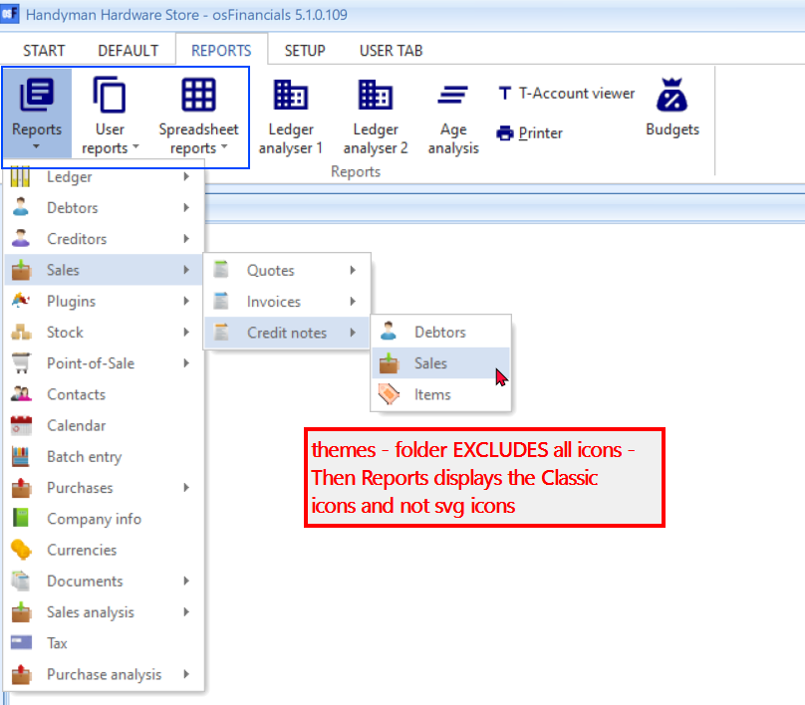

To display the correct svg icons for Reports menu, User reports menu and Excel reports menu, the icons needs to be included in the respective themes folders:

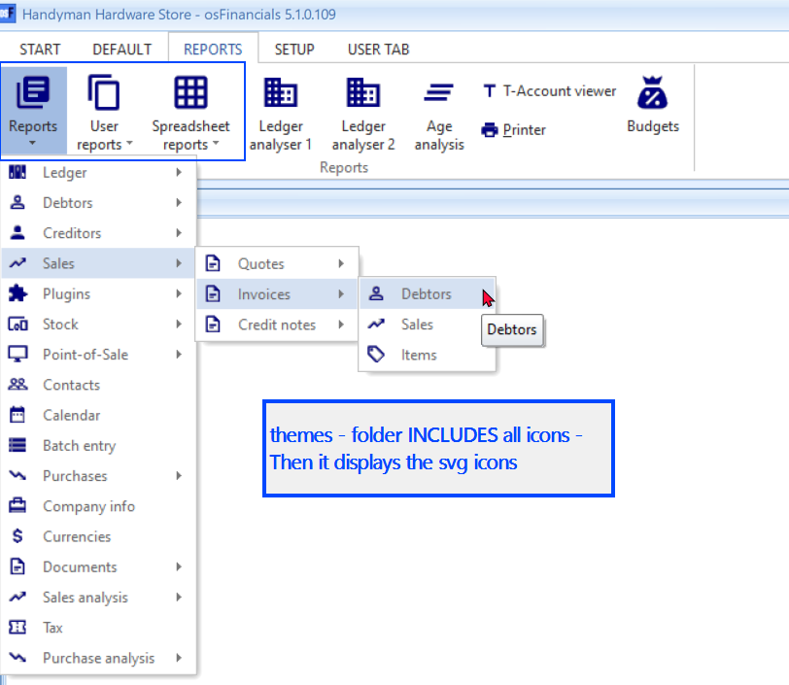

**FIXED - Themes**

***FIXED - Creditor control icon not loading correctly***

The creditor icon - does not change when creating an image strip in all themes - Setup -> Accounts and in Ledger viewer - It is not correctly rendered / displayed.

Checked properties of creditor svg files

Replaced the Acccreditors.svg icons and create image strips

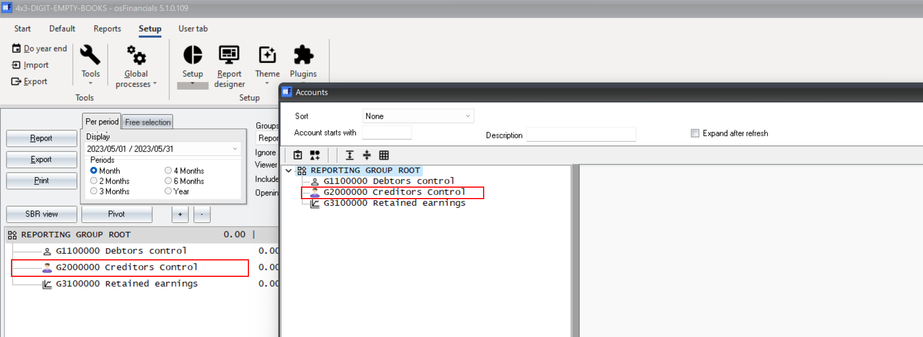

***FIXED - Help.svg with osF icon***

The osF icon is displayed on most themes instead of Help.svg icons.

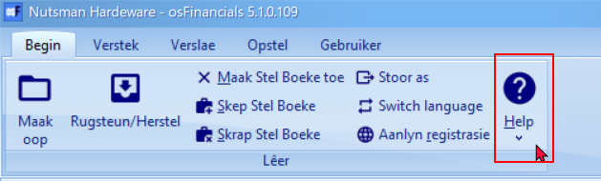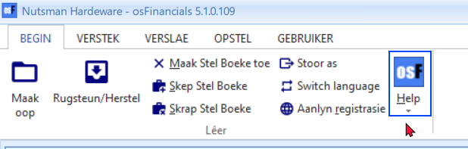

For consistency the Help.svg was removed to display the osF icon from the following themes folders:

1. Glass
2. Silver
3. Soft-blue
4. Material-Blue
5. Material-Navy
6. Material-Maroon

New image strips created to update the changes.